Open Market Review Template

North Lincolnshire Broadband Project

REQUEST FOR INFORMATION

1. INTRODUCTION

North Lincolnshire Broadband Project strive to provide the best broadband connectivity possible across its programme Area. The project was established by North Lincolnshire Council and geographically covers the area of North Lincolnshire. The overarching aspiration of North Lincolnshire Broadband Project is to deliver ‘superfast for all’.

2. GEOGRAPHICAL SCOPE

As described above, our area encompasses the premises that are defined within the accompanying spreadsheet which details the post codes and associated premises count. The postcode data has been sourced from AddressBase Plus, from Ordnance Survey taken July 2019 (Version FULL 2019-07-18 001) and was cleansed in line with the methodology as set by BDUK. A map of this area is shown at the foot of this document and is also available in a GIS format upon request.

3. PROGRESS TO DATE

Our initial Local Broadband Plan secured approval in 2012 covering an Intervention Area of some
31, 000 premises that were assessed as being outside the scope for normal commercial NGA investment through an open market review process.

The phase 1 contract signed in 2013 delivered 92.5% superfast broadband coverage to the Programme Area in 2015, North Lincolnshire Council in partnership with Building Digital UK (BDUK) and Openreach successfully delivered a superfast broadband project in Northern Lincolnshire. As we approach the closure of the phase 2 95% (UK SFB >24mbps) of premises in North Lincolnshire now have access to superfast broadband.

On completion of the phase 2 around 5% of premises do not have access to Next Generation Access, these are made up of the hardest to reach isolated areas in the rural enclaves. The council has estimated there are circa 4000 rural premises that fall into this category.

In June 2019 the council was offered a grant of £1,000,000 from the Rural Payments Agency to support a project to install Next Generation Access (NGA) Broadband Infrastructure to premises across North Lincolnshire.

It is therefore North Lincolnshire Councils intention to procure Next Generation Access solutions – those capable of achieving a minimum of 30 Mbps download speed - for the remaining area in scope for NGA deployment.
_____________________________
OMR Response template will be released to providers once North Lincolnshire Council have received the Ordnance Survey Data: signed PMSA Standard Form Contractor Licence which can be found at the end of this document

4. PURPOSE OF THIS OMR

As part of this new procurement process, we are now commencing an Open Market Review (“OMR”) to establish existing and planned (next 3 years) commercial coverage of broadband services across the North Lincolnshire Broadband Area by all existing and any prospective, NGA broadband infrastructure providers.

This OMR is intended as a precursor to a formal public consultation document. The UK applies a best practice process that promotes the use of both an Open Market Review (“OMR”) and a Public Consultation, the latter being conducted in a manner consistent with the requirements of the Broadband Guidelines. We consider that early market engagement at this stage is an essential and extremely important part of our early market research The results of the OMR will assist us with understanding the broadband infrastructure (Next Generation Access (NGA)) already in place and where there are plans for investment in such infrastructure in the coming three years and a significant step in the design of the intervention area to be targeted by the new contract.

Once we have defined these Intervention Areas from the OMR, we will be conducting a minimum one month State aid public consultation on our proposed Intervention Areas. We propose to launch our ITT in the financial year 2019.

5. YOUR RESPONSE REQUIRED

We are sending this OMR to all recognised broadband infrastructure and internet providers in our area. In addition, we are publishing this OMR document on our website.

We require responses by 3 September 2019 to the questions set out in the Annex.

The OMR Response Template will be issued via email once a signed Partners Standard Form Contractor Licence, which can be found at the end of this document, has been returned to nlbb@northlincs.gov.uk.

Please note that the data you provide in your response will be treated as commercially confidential to North Lincolnshire Council, albeit that it may be necessary to share some/all of your response data with our professional advisors and/or DCMS/BDUK, Ofcom, BIS State Aid Branch and the European Commission in the course of seeking State Aid . It should also be noted that it is a State Aid requirement to utilise this information to produce State Aid maps to define white, grey and black areas for basic and NGA broadband. These maps will be published as part of the Public Consultation process and will be utilised to define the intervention area. However, please note that these published maps will be assimilated utilising data from all relevant operators and will not be directly attributed to a single source.

If you have any questions about any of the above, please contact North Lincolnshire Council, North Lincolnshire Broadband Project, Hewson House, Brigg, DN20 8XB.

Email: nlbb@northlincs.gov.uk or telephone: 01724 297579.

ANNEX
- Please provide details and supporting evidence of any current or planned investment in broadband infrastructure (basic broadband and NGA broadband) in North Lincolnshire area. In the case of planned investment, we are particularly interested in plans for the coming three years (to [3 years from issue date]).

Beyond completion of the attached spreadsheet template (or instead of the spreadsheet if you are not able to provide the information in the required template form), any information provided in response to this request should include but not be limited to:

  - Premises detail for basic broadband and NGA broadband showing the existing coverage and separately maps detailing the planned investment in the basic broadband and NGA infrastructure networks for at least the next three years;

  - Exact detail of premises passed or covered, including information on the number of premises passed (in the case of a fixed network) or covered and able to receive services (in the case of a wireless/satellite network);

  - Details of the technology and where these claim to be NGA, demonstrate how they meet the minimum standards as set-out in the BDUK Technology Guidelines.

  - Description of the services/ products currently offered and separately those to be offered within the next 3 years;

  - Installation and rental tariffs for those services/products clearly identifying whether they are inclusive or exclusive of VAT;

  - Upload and download speeds typically experienced by end users;

  - Appropriate indicators of quality of the service e.g. contention ratio or bandwidth allocation per end user;

  - Evidence to substantiate actual or planned coverage claims including business cases and evidence of available funding to enable plans to be fulfilled.

  - Details and timing of roll-out for future investment; and

  - Confirmation from an authorised signatory that all information provided is of suitable accuracy.

Please supplement with supporting evidence as you consider appropriate e.g. public Websites.

Thank you, North Lincolnshire Council
Map of Geographic area
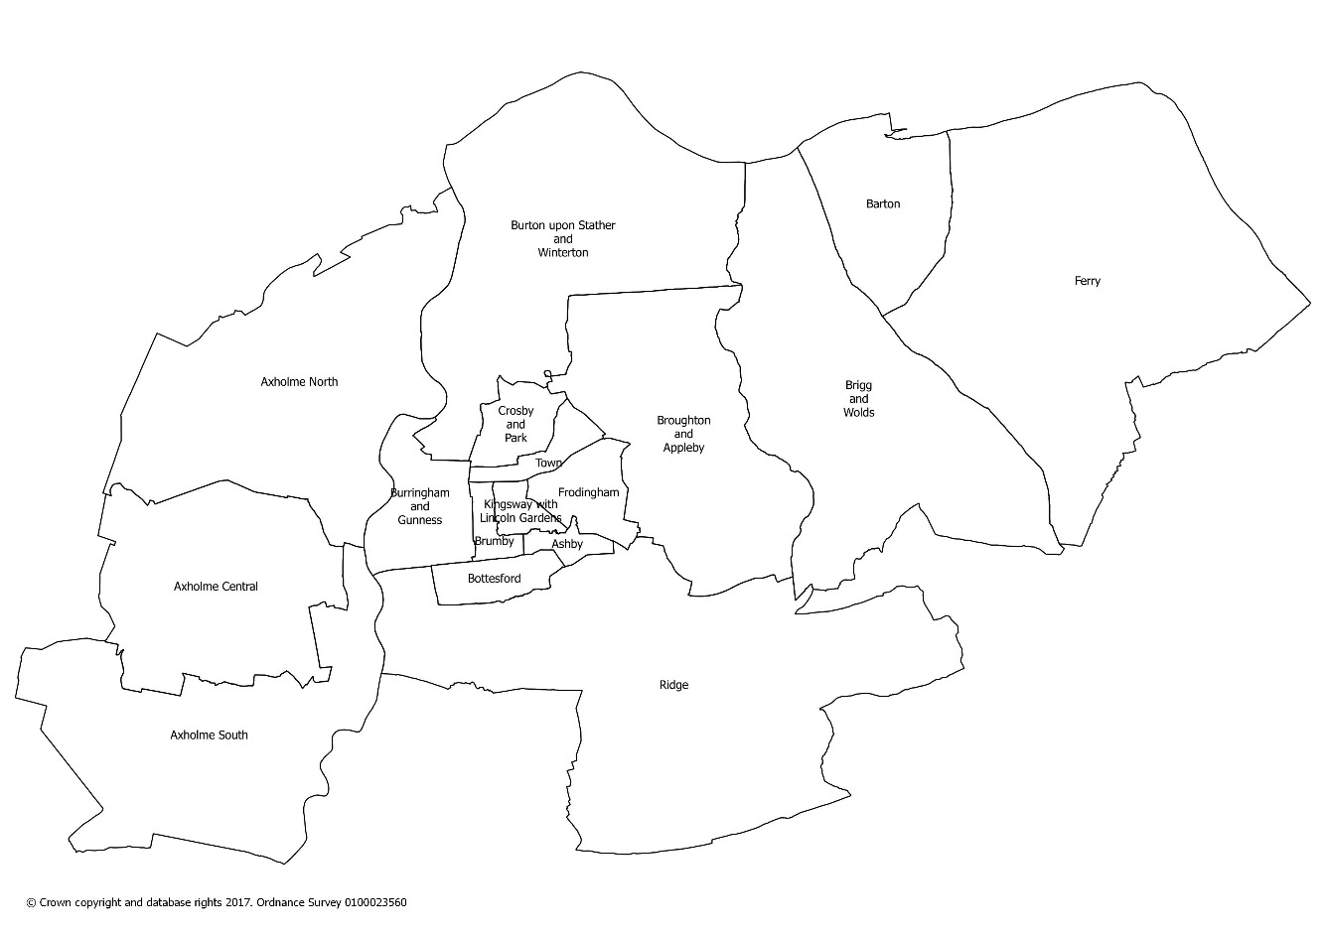

[For implementing bodies using Ordnance Survey data]

PSMA Standard Form Contractor Licence | Premises level

https://www.gov.uk/government/publications/2016-nbs-tech-guidelines

