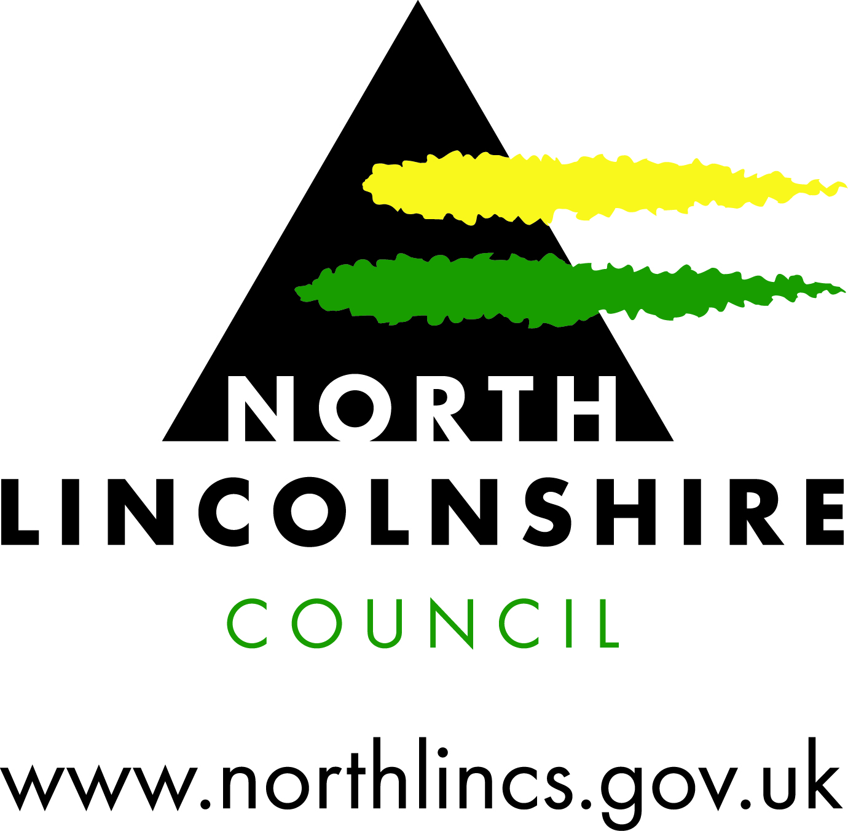

Easy Read

Adult Social Care Annual Report 2017/2018

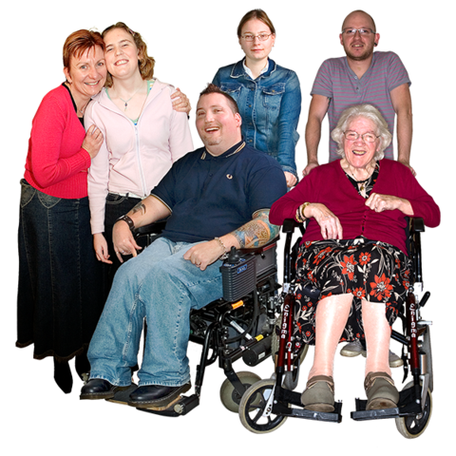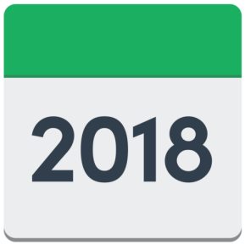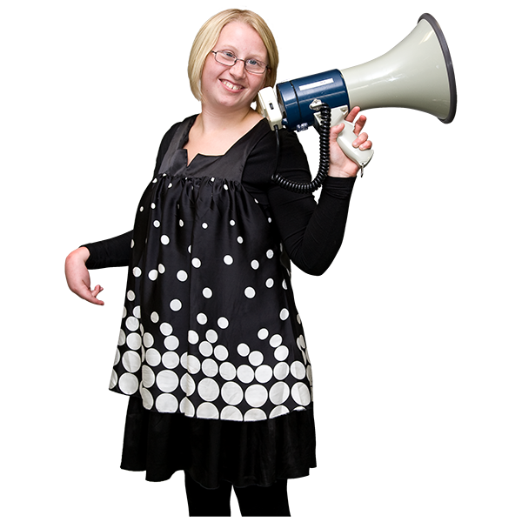

The Adult Social Care Annual Report lets you know how Adult Services in North Lincolnshire have done.

We supported 11,996 people to stay independent.

What did we do in 2017/18?

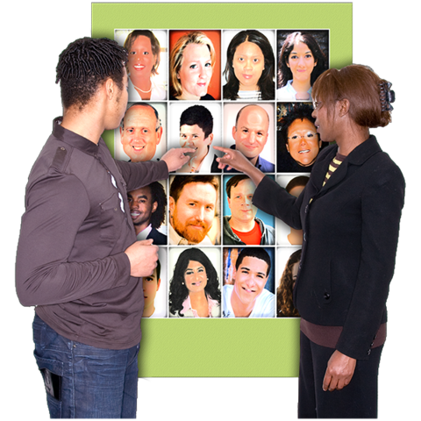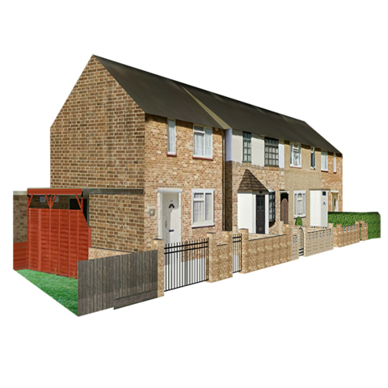

People have told us they are happy with the support we provide.

We helped people have choice and control.

We helped people get home quickly after being in hospital.



We have spent our money well and supported more people than ever.

Next year, we will:

1. Develop housing for people with Dementia.

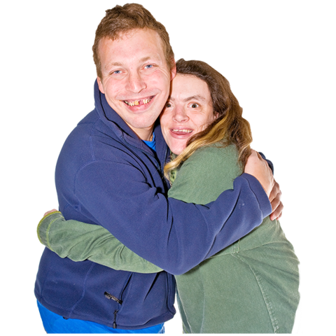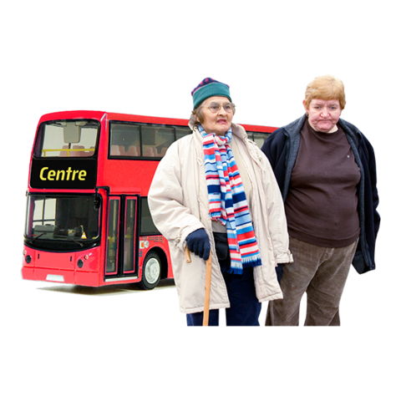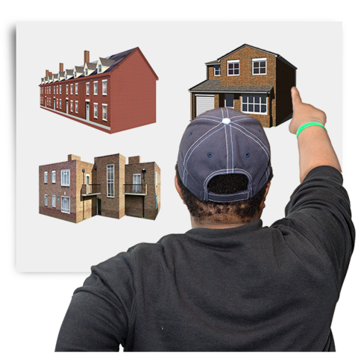

1. Support people to be involved in their community.
2. Create a centre for people who are frail.

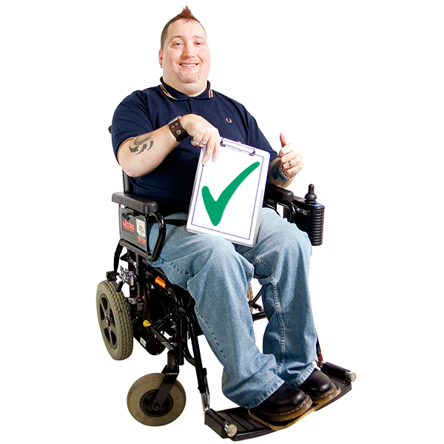

1. Create an ‘Independent Living Centre’ where people can get equipment and advice on how to stay independent.

My Story

Marie fell over on ice and had to go to hospital. We helped her to get healthy again and live independently after her fall.

Marie has a guide dog called Courtney. Whilst she was in hospital, Courtney had to live with a foster family. Marie said she missed Courtney. We supported Marie to get better. Marie is well again and Courtney is back home with Marie.

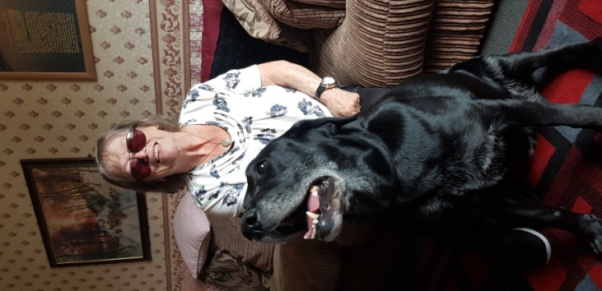

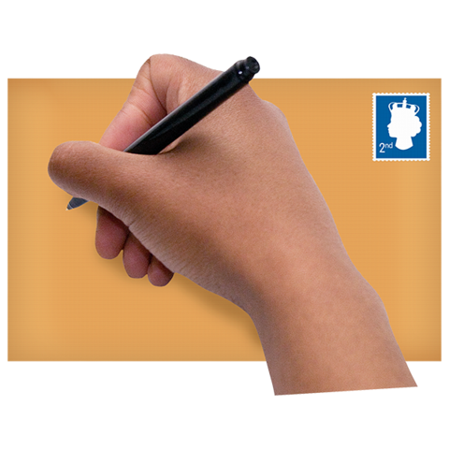 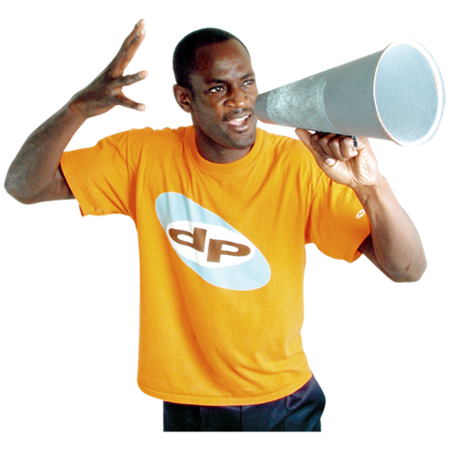

You can tell us your story for the next Adult Social Care Report here: <https://www.research.net/r/RTKLGW5>

Julia Matthews

Adult Services

Hewson House

Station Road

Brigg

North Lincolnshire

DN20 8XB

We want you to tell us what is important to you.